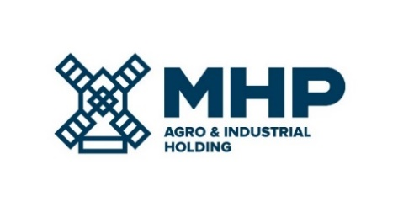

18 April 2024, Limassol, Cyprus
MHP SE
Date Notification - DATE RESCHEDULED

MHP SE (LSE: MHPC), the parent company of a leading international food & agrotech group with headquarters in Ukraine, notifies its stakeholders that the date of publication of its Financial Results for the Fourth Quarter and Twelve Months Ended 31 December 2023 is May 02, 2024.
MHP’s management will host a conference call for investors and analysts followed by Q&A on the day of the results.

The dial-in details are:

Time: | 13.00 London / 15.00 Kyiv / 08.00 New York
Title: | Financial results for Q4 and 12M 2023
UK: | +44 203 984 9844
Ukraine: | +380 89 324 0624
USA: | +1 718 866 4614
PIN code: | 645982

In order to follow the presentation together with the management, please follow the link:
https://mm.closir.com/slides?id=645982

For investor relations enquiries:
Anastasia Sobotyuk (Kyiv) Kyiv: +380 50 339 29 99
Cyprus: +357 99 76 71 26
a.sobotyuk@mhp.com.ua

