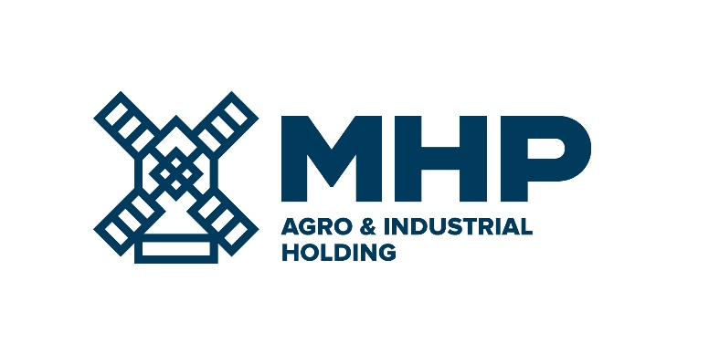
11 March 2024, Limassol, Cyprus
MHP SE
Results of EGM

MHP SE (LSE: MHPC), the parent company of a leading international food and agrotech company with headquarters in Ukraine, today announces that at its Extraordinary General Meeting of shareholders (“Meeting”), held at 16-18, Zinas Kanther Street, Ayia Triada, 3035 Limassol, Cyprus on the 11th day of March 2024 at 12.00 pm, all resolutions were adopted as Ordinary Resolutions.

The agenda of the Meeting was as follows:

1. To approve the remuneration of Mr. Christakis Taoushanis as from 1 January 2024.
2. To approve the remuneration of Mr. Philip J Wilkinson OBE as from 1 January 2024.
3. To approve the remuneration of Mr. John Grant as of 1 January 2024.
4. To approve the remuneration of Mr. Oscar Chemerinski as of 1 January 2024.

NOTE: Please kindly take into account that the name of the International Government Relations & Public Affairs Committee was recently changed to the Sustainability & International Affairs Committee but that the role and authority / role / responsibilities of the Committee remain the same and that any reference to the Committee with the old /previous name shall be read and understood as if reference is made to the same committee but with the new name. There is a reference to the Committee in the Minutes of the EGM.

Please see the Minutes of the EGM here:

https://mhp.com.cy/agm-and-egm/egm/

-Ends-

For Investor Relations enquiries  Anastasiia Sobotiuk (Kyiv) | Kyiv: +38 050 339 29 99  Cyprus: +357 99 76 71 26  a.sobotyuk@mhp.com.ua

