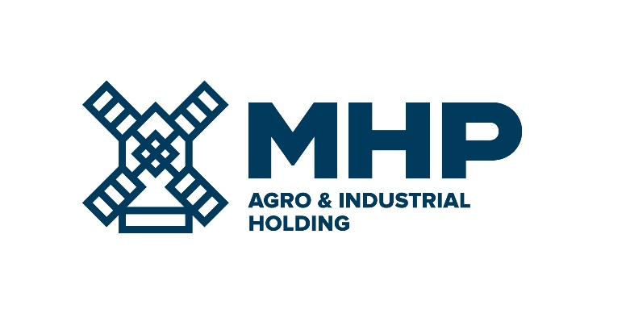
07 March 2023, Limassol, Cyprus

MHP SE
Results of EGM

MHP SE (LSE: MHPC), the parent company of a leading international food and aggrotech company with headquarters in Ukraine, today announces that at its Extraordinary General Meeting of shareholders (“Meeting”), held at 16-18, Zinas Kanther Street, Ayia Triada, 3035 Limassol, Cyprus on the 7th day of March 2023 at 12.00 pm, the resolution was adopted as Ordinary Resolution.

The agenda of the Meeting was as follows:
To appoint Mr. Oscar Chemerinski as an additional Independent Non-Executive Member of the Administrative Organ of the Company from the date of the Extraordinary General Meeting until the Annual General Meeting of the Company to be held in the year 2023.

Please see all documents in respect of Board Meeting following the link:
Extraordinary general meeting – MHP SE
-Ends-

For Investor Relations enquiries  Anastasiia Sobotiuk (Kyiv) | Kyiv: +38 050 339 29 99  Cyprus: +357 99 76 71 26  a.sobotyuk@mhp.com.ua

