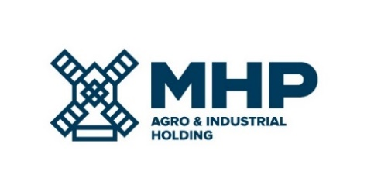

21 March 2023, Limassol, Cyprus
MHP SE
Date Notification - DATE RESCHEDULED

MHP SE (LSE: MHPC), the parent company of a leading international food & agrotech group with headquarters in Ukraine, notifies its stakeholders that the date of publication of Financial Results for the Fourth Quarter and Twelve Months Ended 31 December 2022 has been changed from March 30, 2023 to April 11, 2023.
Due to the ongoing hostilities and the difficult economic situation in Ukraine, EY auditors and the Company require additional time to complete procedures in respect of a regular revaluation of its property, plant and equipment at 31 December 2022. The Company is also obliged to prepare annual report in iXBRL format as required for the periods starting from 1 January 2022 by the FCA regulations. Thus, additional time is required to finalize the audit.
The 2022 financial results are not impacted by the above.
MHP’s management will host a conference call for investors and analysts followed by Q&A on the day of the results.

The dial-in details are:

Time: | 14.00 London / 16.00 Kyiv / 09.00 New York
Title: | Financial results for Q4 and 12M 2022
UK: | +44 203 984 9844
Ukraine: | +380 89 324 0624
USA: | +1 718 866 4614
PIN code: | 645982

In order to follow the presentation together with the management, please follow the link:
https://mm.closir.com/slides?id=645982

For investor relations enquiries:
Anastasia Sobotyuk (Kyiv) Kyiv: +380 50 339 29 99
Cyprus: +357 99 76 71 26
a.sobotyuk@mhp.com.ua

