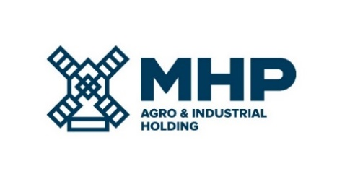

02 September 2022, Limassol, Cyprus
MHP SE
Date Notification - DATE RESCHEDULED
MHP SE (LSE: MHPC), the parent company of a leading international food & agrotech group with headquarters in Ukraine, would like to inform its stakeholders that the date of financial results for Q2 and H1 2022 has been changed from 07 September to 14 September 2022.

MHP’s management will host a conference call for investors and analysts followed by Q&A on the day of the results.

The dial-in details are:

Time: | 14.00 London / 16.00 Kyiv / 09.00 New York
Title: | Financial results for Q2 and H1 2021
UK: | +44 203 984 9844
Ukraine: | +380 89 324 0624
USA: | +1 718 866 4614
PIN code: | 645982

In order to follow the presentation together with the management, please follow the link:
https://mm.closir.com/slides?id=645982

For investor relations enquiries:
Anastasia Sobotyuk (Kyiv) Kyiv: +380 50 339 29 99
Cyprus: +357 99 76 71 26
a.sobotyuk@mhp.com.ua

